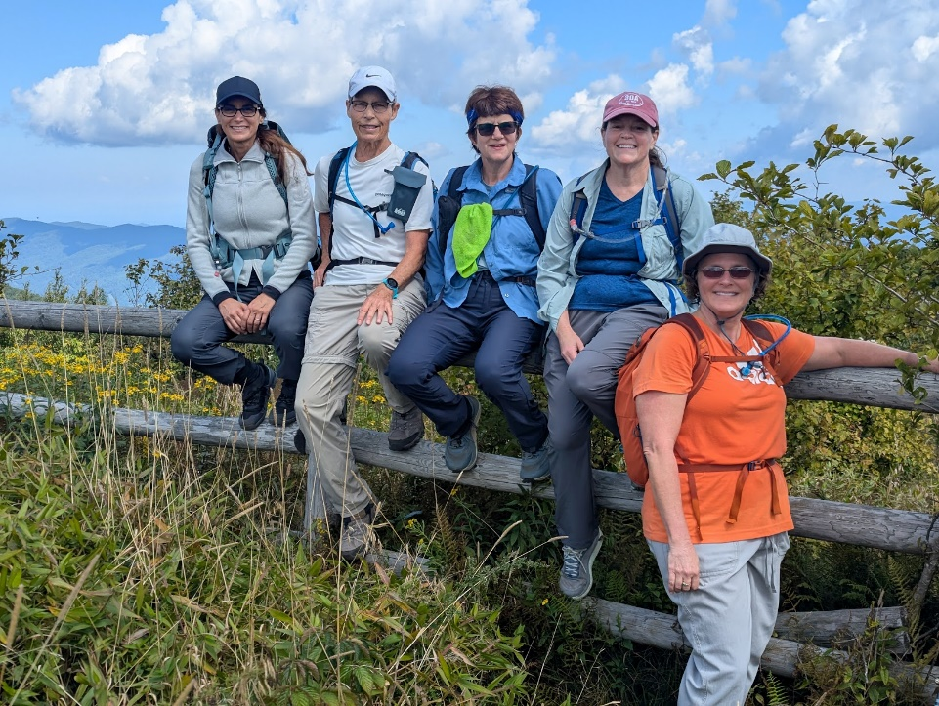
Clayton Georgia Hike
Clayton, Georgia, offers incredible hiking with scenic mountain views and numerous waterfalls, featuring popular hiking areas like the Bartram Trail, the Chattooga River, Tallulah Gorge, and Black Rock Mountain, which provide a variety of trails for different skill levels. These areas offer opportunities to explore diverse terrains, from challenging mountain summits to cascading falls, ensuring a memorable outdoor experience in the Southern Appalachian region
02 April -05 April 2026
3 Day, 30 mile, Hiking trip with overnight stay in an AirB&B
Information Call: Tuesday Jan 6th, 2026 @ 7.30 PM via Google Meet
Admin Fee: $100.00
Sign Up Here!

